Version: RanetPivotTable 5.7.199
2 NEW Drillthrough problems

1. A drillthrough error occurred because the filter set for the hierarchy is empty.
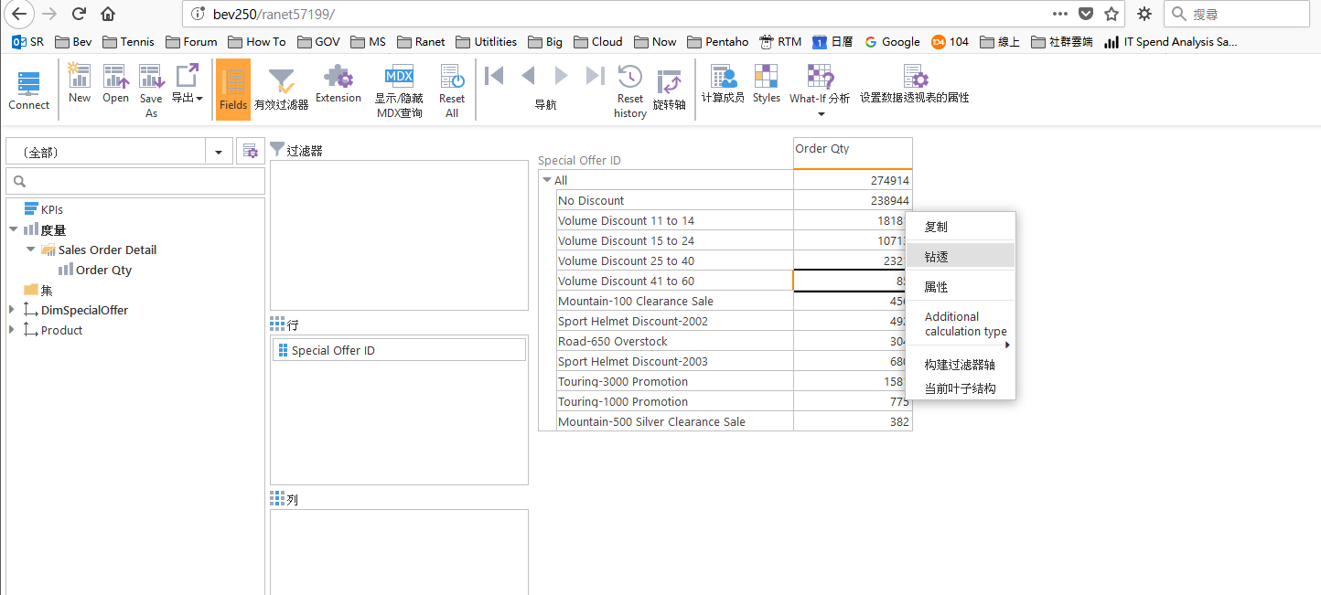
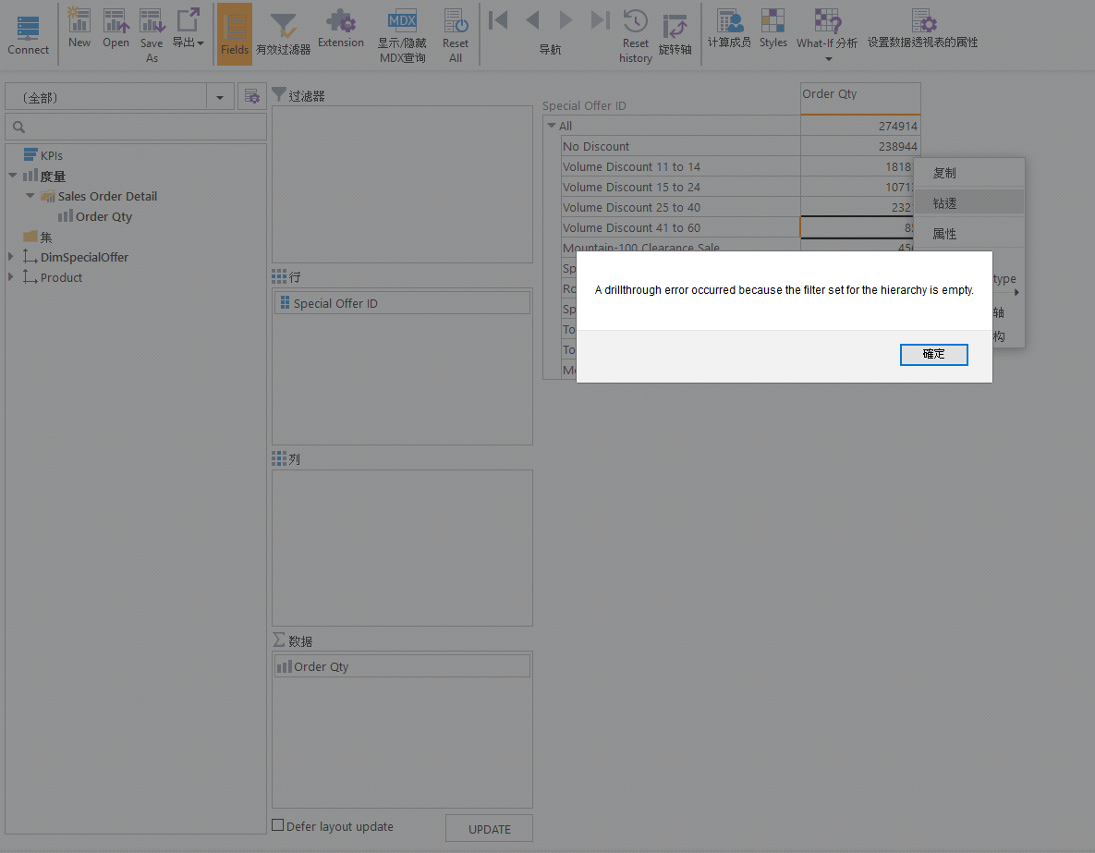

2. A drillthrough error occurred because the filter set for the hierarchy has multiple values selected
